Module 8) Bootstrap Basic & Advanced
1.What are the advantages of Bootstrap?
Ans. Bootstrap is an open-source CSS framework designed to come up with mobile-friendly, responsive front-end web development. It consists of enormous versatile and reusable pieces of code written in HTML, JavaScript, and CSS. As a framework, fundamentals are already placed for responsive web development, and developers simply need to position the code in a premeditated grid system. Therefore, while coming up with a new website or application, Bootstrap is a boon because it waives off the burden of coding from scratch. You can efficiently blend its ready-made coding blocks, CSS-Less functionality, and cross-browser compatibility to save tedious hours of coding.
Due to this whole concept, web designing in a limited period is a reality. Besides, it is equipped with free tools, which helps build some common website interface components, thus adding to the adaptability of the framework.
We hope we cleared the doubt – what is Bootstrap used for? Now, let’s move ahead in the article and learn about the benefits of Bootstrap.
1. Easy initiation
Coding is a hurricane task for a person who is unbeknownst to web development. But the greatest use of Bootstrap in web development is it makes coding hassle-free. Bootstrap handles everything for you. Despite having no extensive knowledge of coding, one can design an enticing landing page using Bootstrap. The only criterion is to have moderate experience of CSS and HTML. Alongside this, the integration process of Bootstrap is easy on existing and newer websites. In your current CSS, you can incorporate diverse platforms, frameworks, elements of Bootstrap without any hassles.
2. Responsiveness
Statistics highlight over 6.4 billion smartphone users worldwide. This study infers smartphone penetration of over 80 percent. And the numbers do not stop here; in fact, they are rising rapidly. Due to this extensive demand, having a mobile-responsive website has become a prerequisite, and this task is a cakewalk with Bootstrap by your side. It has a fluid grid layout, which adapts as per the screen resolution.
3. Highly customizable
You can find an array of templates in Bootstrap. However, if you find them unappealing, you can concoct your customization using the CSS file. Besides, if you cannot spare time to start everything from scratch, you can blend the customization with the existing code and enhance the functionality. All this can be undertaken under the customization page.
4. Extremely user-centric
While creating landing pages, it is very important to design from the user’s point of view. If a landing page is engaging, only then does it appeal to the audience. One of the prominent advantages of Bootstrap is you can design landing pages complementing the audience’s requirements. It comes up with suggestions regarding elements like photos, Call-to-actions (CTA) that look best for your audience and enhance user experience. Moreover, it helps in making easy edits to the landing page elements for reaching out to more audiences.
5. Top-notch support
When using Bootstrap, the only requirement is basic knowledge of coding. However, as a newbie, you might come across an array of problems. It might lead to hesitancy when using Bootstrap. To overcome this problem, Bootstrap comes with a huge support community. Having a support community is a blessing in disguise when using any technology. You get answers to every query. You share the query, and the community will actively help in solving it.
Besides, the creators are always on their toes updating Bootstrap to offer a better experience to the users. With this, you can always avail the best assistance in every circumstance.
6.Cross-browser compatibility
Every user is different, and so is their device. Along with the device, they use varied browsers too. Bootstrap is compatible with the latest versions of all modern browsers and platforms. One of the biggest advantages of using Bootstrap is compatibility across browsers. With Bootstrap by your side, heave a sigh of relief when it comes to displaying your landing page across multiple browsers. Its compatibility with Google Chrome, Firefox, Safari, and Internet Explorer makes it more versatile.
7. JavaScript plugins to your rescue
To make the pages more interactive, one needs elements, like sliders, drop-down menus, tabs, etc. The hunt begins to find complementing plugins to include these elements. But with Bootstrap by your side, you can easily incorporate these components as numerous JavaScript plugins are bundled in the Bootstrap package. Also, adding these functionalities is easy as you just need to write a few lines of code and you are all set. Moreover, with the customization option, you have the liberty to choose particular plugins, helping to maintain minimize file size.
8. Far-reaching popularity
The most crucial advantage of using Bootstrap is its widespread presence. A multinational and global company like Apple utilizes Bootstrap for its Apple Maps and Apple Music web apps. Not just this, but Dropbox, Coursera, and Airbnb have acknowledged the prowess of Bootstrap and are using it to maintain robustness.
9. Ample documentation
When using a framework, the support from the community is priceless, but some prefer referring to written notes. Fortunately, Bootstrap satiates this requirement by providing easy-to-read and efficient documentation on the Bootstrap website. The framework is easy, and the documentation makes it easier to work on UI designing.
10. Updates at the doorstep
Staying updated is the core of any technology. The same thumb rule applies to Bootstrap, which is fully attuned. Its core developers constantly keep the framework updated. They keep a close eye on future web requirements and make changes accordingly. Whenever there is a new update, Bootstrap considers the users to get hold of the latest and most advanced technology available in the industry.
So, these are some vital reasons to use Bootstrap for your web development projects. Apart from this, it offers a chaos-free ambiance and minimal coding, making it extremely easy for a newbie to utilize it. Choosing this framework will ease your life and complement all your requirements. Moreover, if you wish to learn it, then enroll in the best web development course in Pune for productive results.

2. What is a Bootstrap Container, and how does it work?
Ans. Bootstrap Containers are the most basic layout element in Bootstrap. Bootstrap Containers are very essential and basic building blocks of bootstrap that wrap a page’s content. It’s responsible for setting and aligning content within it according to viewport or given device. Containers are defined within the container class (.container). In other words, we can say that containers are established the width for the layout to give the content. Elements and content are added within the container.
Containers are used for many purposes such as –
- It requires use with the default grid system.
- To establish width for the layout to give web content.
- To provide responsive fixed behavior of any web project.
- To sets the content margin dealing with the responsive behavior of your layout.
Basically, there are three types of container classes available in bootstrap:
- Default-Container(container)
- Responsive-Container(along with sm, md, lg, xl, xxl)
- Fluid-Container(container-fluid)
1. Default-Container: The default container uses ‘.container’ class. It provides a responsive fixed-width container.
Syntax:
<div class="container">
<!-- Content here -->
</div>
2. Responsive-Container: Responsive containers are responsive in nature. Responsive containers allow you to specify a class that is wide until the specified breakpoint is reached, after which we apply max-widths for each of the higher breakpoints.
Syntax:
<div class="container-sm">Wide for small breakpoint</div>
<div class="container-md">Wide for medium breakpoint</div>
<div class="container-lg">Wide for large breakpoint</div>
<div class="container-xl">Wide for extra large breakpoint</div>
<div class="container-xxl">Wide for extra large breakpoint</div>
3. Fluid-Container: Fluid-container uses the ‘.container-fluid’ class. It is used for a full-width container, spanning the entire width of the viewport.
Syntax:
<div class="fluid-container">
<!-- Content here -->
</div>
Example-1:- In this example, we will see how to use the default container ‘.container” class in bootstrap and know how it’s used along within a webpage.
<!DOCTYPE html>
<html lang="en">
<head>
<meta charset="UTF-8">
<meta http-equiv="X-UA-Compatible" content="IE=edge">
<meta name="viewport" content="width=device-width, initial-scale=1.0">
<title>Document</title>
<link rel="stylesheet" href=
"https://maxcdn.bootstrapcdn.com/bootstrap/3.3.6/css/bootstrap.min.css">
<script src=
"https://ajax.googleapis.com/ajax/libs/jquery/1.12.0/jquery.min.js">
</script>
<script src=
"https://maxcdn.bootstrapcdn.com/bootstrap/3.3.6/js/bootstrap.min.js">
</script>
</head>
<body>
<div class="container"
style="background-color: yellow;">

<h1>Default-Container</h1>

<p>
This is the example of
container in bootstrap
</p>
</div>
</body>
</html>
Output:-
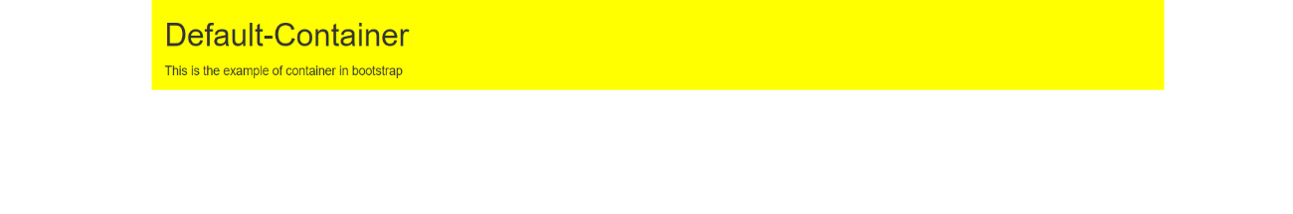

Example 2: In this example, we will see the example of responsive-container uses like ‘.container-sm’ etc., class in bootstrap, and know how it’s used along within a webpage.
<!DOCTYPE html>
<html lang="en">
<head>
<meta charset="UTF-8">
<meta http-equiv="X-UA-Compatible" content="IE=edge">
<meta name="viewport" content="width=device-width, initial-scale=1.0">
<title>Document</title>
<link rel="stylesheet" href=
"https://maxcdn.bootstrapcdn.com/bootstrap/3.3.6/css/bootstrap.min.css">
<script src=
"https://ajax.googleapis.com/ajax/libs/jquery/1.12.0/jquery.min.js">
</script>
<script src=
"https://maxcdn.bootstrapcdn.com/bootstrap/3.3.6/js/bootstrap.min.js">
</script>
</head>
<body>
<div class=" container container-sm"
style="background-color: green;">

<h1>Responsive-Container</h1>

<p>
This is the example of
container in bootstrap
</p>
</div>
</body>
</html>
Output:-
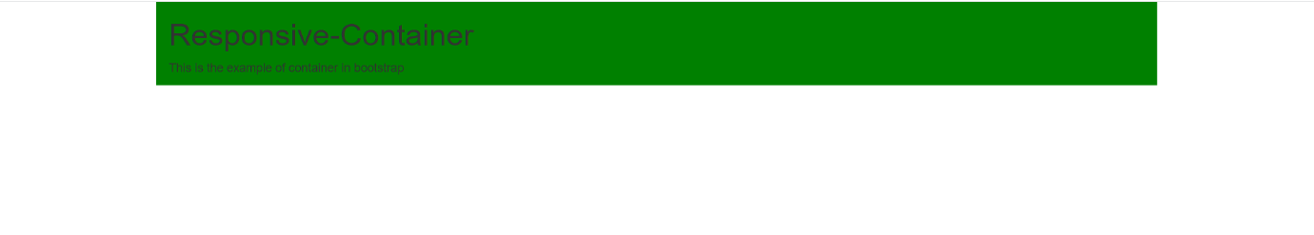

Example 3: In this example, we will see the use of fluid-container ‘.container-fluid” class in bootstrap and know how it’s used along within a webpage.
<!DOCTYPE html>
<html lang="en">
<head>
<meta charset="UTF-8">
<meta http-equiv="X-UA-Compatible" content="IE=edge">
<meta name="viewport" content="width=device-width, initial-scale=1.0">
<title>Document</title>
<link rel="stylesheet" href=
"https://maxcdn.bootstrapcdn.com/bootstrap/3.3.6/css/bootstrap.min.css">
<script src=
"https://ajax.googleapis.com/ajax/libs/jquery/1.12.0/jquery.min.js">
</script>
<script src=
"https://maxcdn.bootstrapcdn.com/bootstrap/3.3.6/js/bootstrap.min.js">
</script>
</head>
<body>
<div class=" container-fluid"
style="background-color: blue;">

<h1>Fluid-Container</h1>

<p>
This is the example of
container in bootstrap
</p>
</div>
</body>
</html>
Output:-
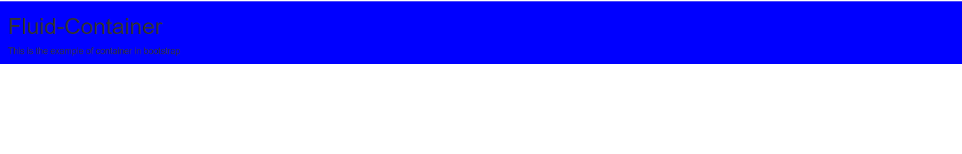

3.What are the default Bootstrap text settings?
Ans. Bootstrap 4 Default Settings
Bootstrap 4 uses a default font-size of 16px, and its line-height is 1.5. The default font-family is "Helvetica Neue", Helvetica, Arial, sans-serif. In addition, all <p> elements have margin-top: 0 and margin-bottom: 1rem (16px by default).

4.What do you know about the Bootstrap Grid System?

Ans. Bootstrap Grid System
- Introduction and Installation
- Buttons, Glyphicons, Tables
- Vertical Forms, Horizontal Forms, Inline Forms
- DropDowns and Responsive Tabs
- Progress Bar and Jumbotron
Prerequisites: Web Development Basics and BootStrap (Part-1)
Grid System: In the previous article we had learnt about Bootstrap and its Installation.However, from this article, we are going to start with learning Bootstrap. We are going to talk about the Bootstrap Grid System in this article.
Grid System: Bootstrap Grid System allows up to 12 columns across the page. You can use each of them individually or merge them together for wider columns. You can use all combinations of values summing up to 12. You can use 12 columns each of width 1, or use 4 columns each of width 3 or any other combination.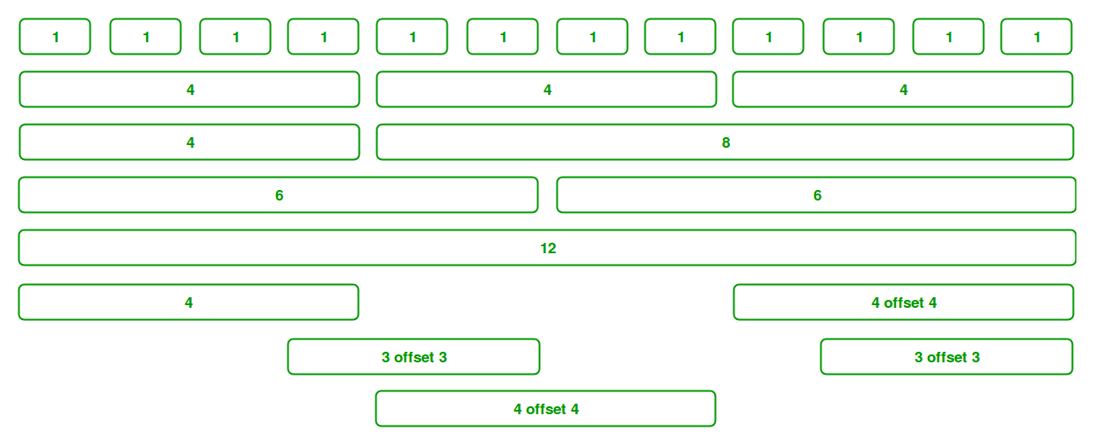
Grid Classes: The Bootstrap grid system has four classes that can be combined to make more flexible layouts:
- xs (<576px): For Portrait Mobile Phones.
- sm (>=576px): For Landscapes phones
- md (>=768px): For Tablets/Phablets
- lg (>=992px): For Small-sized Desktops/Laptops
- xl (>=1200px): For Larger-sized Desktops/Laptops
Note: Output can be little difference as shown, it depend on your screen size.
Components of Grid System: We will be learning the Components of the Grid system one-by-one:
- Containers: Bootstrap requires a containing element to wrap site contents and house our grid system. The word ‘container’ is a container of row elements and row elements are ‘containers’ of the column elements. You will understand it more in the latter part of the article where we have dealt with columns.
Use ‘container’ for a responsive fixed width container and use ‘container-fluid’ for a full width container, spanning the entire width of your viewport.
Example:
<!DOCTYPE html>
<html lang="en">
<head>
<meta charset="UTF-8">
<meta http-equiv="X-UA-Compatible" content="IE=edge">
<meta name="viewport" content="width=device-width, initial-scale=1.0">
<title>Document</title>
<link rel="stylesheet" href=
"https://maxcdn.bootstrapcdn.com/bootstrap/3.3.6/css/bootstrap.min.css">
<script src=
"https://ajax.googleapis.com/ajax/libs/jquery/1.12.0/jquery.min.js">
</script>
<script src=
"https://maxcdn.bootstrapcdn.com/bootstrap/3.3.6/js/bootstrap.min.js">
</script>
</head>
<body>
<header>
<div class="container">
<h1 style="color: green">Tops Technologies</h1>
<strong>A computer Science portal for Tops</strong>
</div>
</header>
<footer>
<hr/>
<div class="container">
<p>
<a href=" https://www.tops-int.com/">
Visit
</a>
our website
</p>
<p>
<a href="https://www.facebook.com/TOPSTech/">
Like
</a>
us on facebook
</p>
</div>
</footer>
</body>
</html>
Output:-


Note: The <div> tag defines a division or a section in an HTML document. The <div> tag is used to group block-elements to format them with CSS.
Rows: Rows must be placed within a ‘container’ or ‘container-fluid’ for proper alignment and padding. We use rows to create horizontal groups of columns.
Example:
<!DOCTYPE html>
<html lang="en">
<head>
<meta charset="UTF-8">
<meta http-equiv="X-UA-Compatible" content="IE=edge">
<meta name="viewport" content="width=device-width, initial-scale=1.0">
<title>Document</title>
<link rel="stylesheet" href=
"https://maxcdn.bootstrapcdn.com/bootstrap/3.3.6/css/bootstrap.min.css">
<script src=
"https://ajax.googleapis.com/ajax/libs/jquery/1.12.0/jquery.min.js">
</script>
<script src=
"https://maxcdn.bootstrapcdn.com/bootstrap/3.3.6/js/bootstrap.min.js">
</script>
</head>
<body>
<header>
<div class="container">
<h1 style="color: green">Tops Technologies</h1>
<strong>
A computer Science portal for Tops
</strong>
</div>
</header>
<div class="container">
<div class="row">
<div class="bg bg-primary w-100">
First row
</div>
</div>
<div class="row">
<div class="bg bg-success w-100">
Second row
</div>
</div>
<div class="row">
<div class="bg bg-primary w-100">
Third row
</div>
</div>
<div class="row">
<div class="bg bg-success w-100">
Fourth row
</div>
</div>
<div class="row">
<div class="bg bg-primary w-100">
Fifth row
</div>
</div>
</div>
<footer>
<hr />
<div class="container">
<p>
<a href="https://www.tops-int.com/">
Visit
</a>
our website
</p>
<p>
<a href="https://www.facebook.com/TOPSTech/">
Like
</a>
us on facebook
</p>
</div>
</footer>
</body>
</html>
Output:-
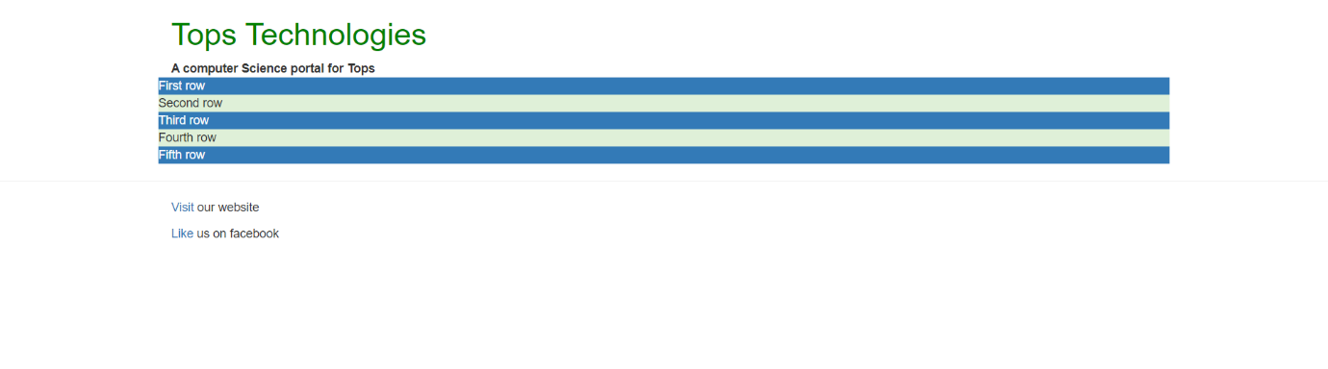

5.What is the difference between Bootstrap 4 and Bootstrap 5
Ans.

Difference between Bootstrap 4 and Bootstrap 5
BASIS OF | BOOTSTRAP 4 | BOOTSTRAP 5
Grid System | It has 5 tier (xs, sm, md, lg, xl). | It has 6 tier (xs, sm, md, lg, xl, xxl).
Color | It has limited colors. | Extra colors added with the looks, A card improved color palette. there are various shades available to choose.
Jquery | It has jquery and all related plugins. | Jquery is removed and switched to vanilla JS with some working plugins
Internet Explorer | Bootstrap 4 supports both IE 10 and 11. | Bootstrap 5 doesn’t support IE 10 and 11.
Form elements | Radio buttons, checkboxes have different look in different OS and browsers. The form uses whatever default browsers provide. | The look of form elements will not change, on different OS or browser. The forms can be customized and form controls can be added, they would not depend on browser.
Utilities API | We cannot modify utilities in bootstrap 4 | Bootstrap 5 gave freedom to modify and also create our own utility
Gutter | We use .glutter with fontsize in px | We use .g* with fontsize in rem
Vertical Classes | Columns can be positioned relative | Columns cannot be positioned relative
Bootstrap Icons | Bootstrap 4 doesn’t have its own SVG icons, we have to use font-awesome for icons. | Bootstrap 5 have its own SVG icons
Jumbotron | It supports. | It doesn’t support jumbotron.
Card deck | The card deck is used to create an isset of cards with equal width and height. | Card deck class in removed in bootstrap
Navbar | We have inline-block property and we will get white dropdown as default for dropdown-menu-dark class. | Inline-block property is removed and we will get black dropdown as default for dropdown-menu-dark class.
Static Site Generator | Bootstrap 4 uses Jekyll software. | Bootstrap 5 uses Hugo software as it is fast static site generator.
flexbox grid | this makes easier to implement vertical designs, and the columns and rows can easily be implemented. the classes justify-center-content can directly be used to align according to the requirement. | advanced grid system is made available , also columns don’t have relative positions.
RTL Support | It does not enable RTL(Right to Left) switching. | It enables RTL(Right to Left) switching.
Offcanvas Component | It does not support Offcanvas Component. | It supports Offcanvas Component(that is it is available now).

6. What is a Button Group, and what is the class for a basic Button Group?
Ans.
“Button Groups” in Bootstrap is a class of name “btn-group” which is used to create series of buttons in groups (without spaces) vertically or horizontally.
This is the basic syntax of the button group class where each button has its own class of “btn”.
<div class="btn-group">
<button type="button" class="btn">Click</button>
</div>
Buttons have a default border-radius on the first and last buttons of the group.
Adding Styles on Buttons: Bootstrap allows you to add styles to your buttons using the following classes:
- .btn-default
- .btn-primary
- .btn-success
- .btn-info
- .btn-warning
- .btn-danger
- .btn-link

Example:
<!DOCTYPE html>
<html lang="en">
<head>
<meta charset="UTF-8">
<meta http-equiv="X-UA-Compatible" content="IE=edge">
<meta name="viewport" content="width=device-width, initial-scale=1.0">
<title>Document</title>
<link rel="stylesheet" href=
"https://maxcdn.bootstrapcdn.com/bootstrap/3.3.6/css/bootstrap.min.css">
<script src=
"https://ajax.googleapis.com/ajax/libs/jquery/1.12.0/jquery.min.js">
</script>
<script src=
"https://maxcdn.bootstrapcdn.com/bootstrap/3.3.6/js/bootstrap.min.js">
</script>
</head>
<body>
<div class="btn-group">
<button type="button" class="btn btn-danger">Click</button>
<button type="button" class="btn btn-warning">Click</button>
<button type="button" class="btn btn-success">Click</button>
</div>
</body>
</html>
Output:-
Sizing of your Buttons: Bootstrap provides 4 button sizes which you can add directly to your buttons by adding an additional class of “btn-group-*” to your “btn-group” class. No need to add separate classes to each button.
<!DOCTYPE html>
<html lang="en">
<head>
<meta charset="UTF-8">
<meta http-equiv="X-UA-Compatible" content="IE=edge">
<meta name="viewport" content="width=device-width, initial-scale=1.0">
<title>Document</title>
<link rel="stylesheet" href=
"https://maxcdn.bootstrapcdn.com/bootstrap/3.3.6/css/bootstrap.min.css">
<script src=
"https://ajax.googleapis.com/ajax/libs/jquery/1.12.0/jquery.min.js">
</script>
<script src=
"https://maxcdn.bootstrapcdn.com/bootstrap/3.3.6/js/bootstrap.min.js">
</script>
</head>
<body>
<div class="btn-group btn-group-lg">
<button type="button" class="btn btn-danger">Click</button>
<button type="button" class="btn btn-warning">Click</button>
<button type="button" class="btn btn-success">Click</button>
</div>
<div class="btn-group">
<button type="button" class="btn btn-danger">Click</button>
<button type="button" class="btn btn-warning">Click</button>
<button type="button" class="btn btn-success">Click</button>
</div>
<div class="btn-group btn-group-sm">
<button type="button" class="btn btn-danger">Click</button>
<button type="button" class="btn btn-warning">Click</button>
<button type="button" class="btn btn-success">Click</button>
</div>
<div class="btn-group btn-group-xs">
<button type="button" class="btn btn-danger">Click</button>
<button type="button" class="btn btn-warning">Click</button>
<button type="button" class="btn btn-success">Click</button>
</div>
</body>
</html>
Output:-
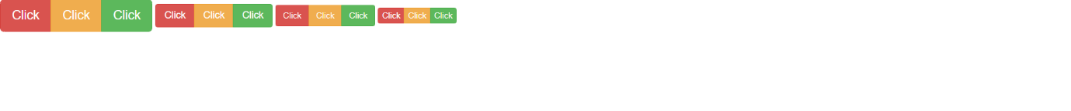

Vertical Button Groups: Bootstrap also supports vertical button groups stacked in a vertical manner rather than horizontal. Use the class “btn-group-vertical” to create a vertical button group:
<!DOCTYPE html>
<html lang="en">
<head>
<meta charset="UTF-8">
<meta http-equiv="X-UA-Compatible" content="IE=edge">
<meta name="viewport" content="width=device-width, initial-scale=1.0">
<title>Document</title>
<link rel="stylesheet" href=
"https://maxcdn.bootstrapcdn.com/bootstrap/3.3.6/css/bootstrap.min.css">
<script src=
"https://ajax.googleapis.com/ajax/libs/jquery/1.12.0/jquery.min.js">
</script>
<script src=
"https://maxcdn.bootstrapcdn.com/bootstrap/3.3.6/js/bootstrap.min.js">
</script>
</head>
<body>
<div class="btn-group-vertical">
<button type="button" class="btn btn-danger">Click</button>
<button type="button" class="btn btn-warning">Click</button>
<button type="button" class="btn btn-success">Click</button>
</div>
</body>
</html>
Output:-
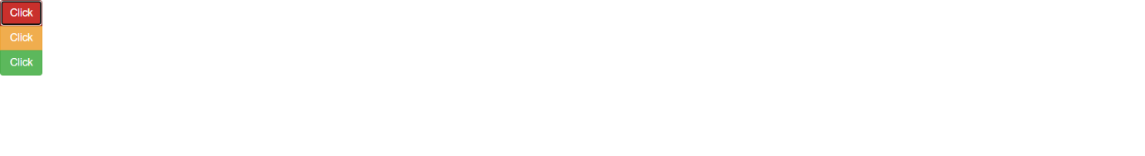

Nesting of Buttons: Bootstrap allows you to create dropdown menus under your buttons through nesting. Add a class of “btn-group” within your main “btn-group” class to have a dropdown menu within your button:

7. How can you use Bootstrap to make thumbnails?
Ans.
Bootstrap helps web developers to create thumbnails that are used to show linked images in grids with the pre-defined classes which help to reduce codes length. Thumbnails are created to provide a quick preview of images with small images.
Thumbnail Image: A thumbnail is a small image that represents a larger image. Bootstrap has an easy way to do this with thumbnails. Bootstrap’s .thumbnail class is used to show linked images in grids (grid system), a thumbnail is created using class .thumbnail within the element <a>. The class .col-sm-* and .col-md-* (where * represent number ), it is used to create grids of the images.
Step by step guide for the implementation:
Step 1: Include Bootstrap and jQuery CDN into the <head> tag before all other stylesheets to load our CSS.
<link rel=”stylesheet” href=”http://maxcdn.bootstrapcdn.com/bootstrap/3.3.6/css/bootstrap.min.css”>
<script src=”https://ajax.googleapis.com/ajax/libs/jquery/1.12.0/jquery.min.js”></script>
<script src=”http://maxcdn.bootstrapcdn.com/bootstrap/3.3.6/js/bootstrap.min.js”></script>
Step 2: Add <div> tag in the HTML body with class row. In that <div> create four div sections to create four images.
Step 3: Add “col-sm-6” and “col-md-3” to four div sections which creates webpage responsive.
Step 4: Add <a> tag with class value thumbnail to define the link of the image in the next line.
<a href="#" class="thumbnail">
Example 1: The following example shows the creation of thumbnails images.
<!DOCTYPE html>
<html lang="en">
<head>
<title>Thumbnail images</title>
<link
rel="stylesheet"
href=
"http://maxcdn.bootstrapcdn.com/bootstrap/3.3.6/css/bootstrap.min.css"/>
<script src=
"https://ajax.googleapis.com/ajax/libs/jquery/1.12.0/jquery.min.js">
</script>
<script src=
"http://maxcdn.bootstrapcdn.com/bootstrap/3.3.6/js/bootstrap.min.js">
</script>
</head>
<body>
<h3 style="color: green">Bootstrap thumbnails</h3>
<div class="row">
<div class="col-sm-6 col-md-3">
<a href="#" class="thumbnail">
<img src="https://www.nato.int/nato_static_fl2014/assets/pictures/images_mfu/2020/6/stock/200612-dsg-workshop.jpg"
style="height: 100px; width: 100px"/>
</a>
</div>
<div class="col-sm-6 col-md-3">
<a href="#" class="thumbnail">
<img src="https://blog.vantagecircle.com/content/images/2020/08/technology-in-the-workplace.png"
style="height: 100px; width: 100px"/>
</a>
</div>
<div class="col-sm-6 col-md-3">
<a href="#" class="thumbnail">
<img src="https://encrypted-tbn0.gstatic.com/images?q=tbn:ANd9GcSAGEYGzHea6VYaypGpb_le6fKkVjeVKR01mA&usqp=CAU"
style="height: 100px; width: 100px"/>
</a>
</div>
<div class="col-sm-6 col-md-3">
<a href="#" class="thumbnail">
<img src="https://encrypted-tbn0.gstatic.com/images?q=tbn:ANd9GcQpQQKuJAtMkiUzoRYYkJ530mDRuOhXDaDQQTyd55Fgq17cT_bZmsu-EPUfMxhLbZ51OKU&usqp=CAU"
style="height: 100px; width: 100px"/>
</a>
</div>
</div>
</body>
</html>
Output:-
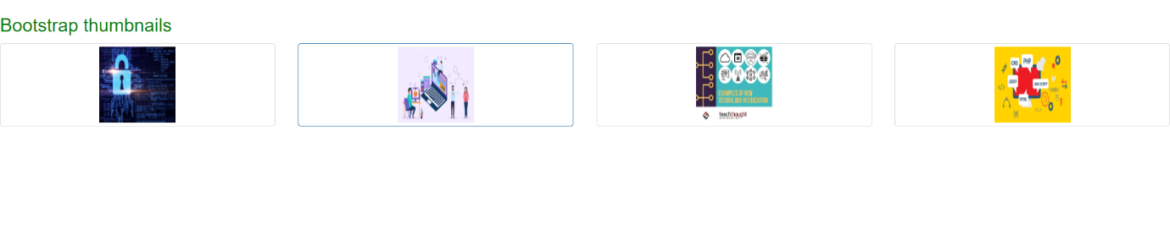

Adding captions and buttons to the thumbnails :
Step 1: We created div with class value as thumbnail and inserted image, after that add div with class .caption to define the description of the images <p>.
Step 2: Create buttons using <a> tag with class . btn .btn-success.
Example: The following example demonstrates adding of caption and button to the thumbnails.
<!DOCTYPE html>
<html lang="en">
<head>
<link
rel="stylesheet"
href=
"http://maxcdn.bootstrapcdn.com/bootstrap/3.3.6/css/bootstrap.min.css"/>
<script src=
"https://ajax.googleapis.com/ajax/libs/jquery/1.12.0/jquery.min.js">
</script>
<script src=
"http://maxcdn.bootstrapcdn.com/bootstrap/3.3.6/js/bootstrap.min.js">
</script>
</head>
<body>
<h3 style="color: green">
<b>Bootstrap Thumbnails with Captions and Button</b>
</h3>
<div class="row">
<div class="col-sm-6 col-md-3">
<a href="#" class="thumbnail">
<img src="https://www.nato.int/nato_static_fl2014/assets/pictures/images_mfu/2020/6/stock/200612-dsg-workshop.jpg"
style="height: 100px; width: 100px"/>
</a>
<div class="caption">
<h3 style="color: green">Web-Development</h3>

<p>
Web development refers to the building,
creating, maintaining of
websites.
</p>

<p>
<a href="#" class="btn btn-success">
Learn More
</a>
</p>

</div>
</div>
<div class="col-sm-6 col-md-3">
<a href="#" class="thumbnail">
<img src="https://blog.vantagecircle.com/content/images/2020/08/technology-in-the-workplace.png"
style="height: 100px; width: 100px"/>
</a>
<div class="caption">
<h3 style="color: green">Machine Learning</h3>

<p>
Machine Learning is the study to
learn without being explicitly
programmed.
</p>

<p>
<a href="#" class="btn btn-success">
Learn More
</a>
</p>

</div>
</div>
<div class="col-sm-6 col-md-3">
<a href="#" class="thumbnail">
<img src="https://encrypted-tbn0.gstatic.com/images?q=tbn:ANd9GcSAGEYGzHea6VYaypGpb_le6fKkVjeVKR01mA&usqp=CAU"
style="height: 100px; width: 100px"/>
</a>
<div class="caption">
<h3 style="color: green">Programming</h3>

<p>
Competitive Programming enables you
to code a given problem under
provided constraints.
</p>

<p>
<a href="#" class="btn btn-success">
Learn More
</a>
</p>

</div>
</div>
<div class="col-sm-6 col-md-3">
<a href="#" class="thumbnail">
<img src="https://encrypted-tbn0.gstatic.com/images?q=tbn:ANd9GcQpQQKuJAtMkiUzoRYYkJ530mDRuOhXDaDQQTyd55Fgq17cT_bZmsu-EPUfMxhLbZ51OKU&usqp=CAU"
style="height: 100px; width: 100px"/>
</a>
<div class="caption">
<h3 style="color: green">Java</h3>

<p>
Java is one of the most popular
and widely used programming
language.
</p>

<p>
<a href="#" class="btn btn-success">
Learn More
</a>
</p>

</div>
</div>
</div>
</body>
</html>
Output:-
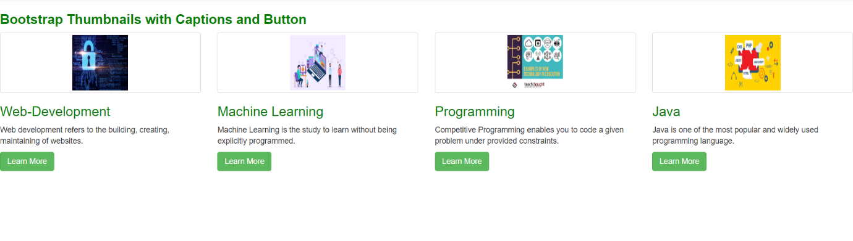

8. In Bootstrap 4, what is flexbox?
Ans.
Bootstrap 4
, flex box is used to control the layout and alignment specification of Bootstrap 4 components. This box makes it easier to design flexible responsive layout structures without using float or positioning attributes.
<! DOCTYPE html>
<html lang="en">
<head>
<title> Bootstrap 4 vertical Flex Box Example </title>
<meta charset="utf-8">
<meta name="viewport" content="width=device-width, initial-scale=1">
<link rel="stylesheet" href="https://maxcdn.bootstrapcdn.com/bootstrap/4.5.2/css/bootstrap.min.css">
<script src="https://ajax.googleapis.com/ajax/libs/jquery/3.5.1/jquery.min.js"> </script>
<script src="https://cdnjs.cloudflare.com/ajax/libs/popper.js/1.16.0/umd/popper.min.js"> </script>
<script src="https://maxcdn.bootstrapcdn.com/bootstrap/4.5.2/js/bootstrap.min.js"> </script>
</head>
<style>
h2 {
position: relative;
padding: 10;
margin: 10;
font-family: "Raleway", sans-serif;
font-weight: 300;
font-size: 40px;
color: white;
text-align: center;
-webkit-transition: all 0.4s ease 0s;
-o-transition: all 0.4s ease 0s;
transition: all 0.4s ease 0s;
}
body {
background-size: 400% 400%;
margin: 2rem;
background: linear-gradient(-45deg, #ee7752, #e73c7e, #23a6d5, #23d5ab);
animation: gradient 15s ease infinite;
height: 100vh;
}
@keyframes gradient {
0% {
background-position: 0% 50%;
}
50% {
background-position: 100% 50%;
}
100% {
background-position: 0% 50%;
}
}
</style>
<body>
<div class="container mt-3">
<h2> Bootstrap 4 Vertical Direction flexbox </h2>
<p> Use .flex-column-reverse to reverse the vertical direction: </p>
<div class="d-flex flex-column-reverse">
<div class="p-2 bg-info"> Flex item 1 </div>
<div class="p-2 bg-warning"> Flex item 2 </div>
<div class="p-2 bg-primary"> Flex item 3 </div>
</div>
</div>
</body>
</html>
Output:-
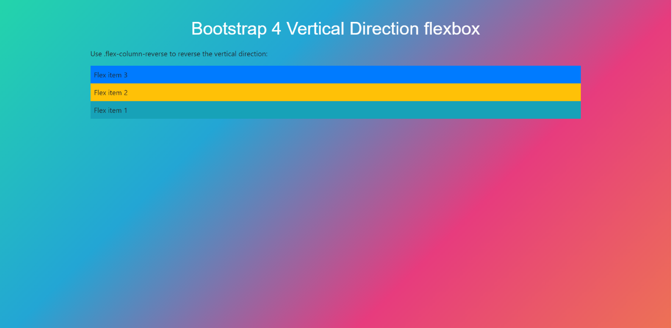

9. How can one create an alert in Bootstrap?
Ans.
Approach: The .alert class followed by contextual classes are used to display the alert message on website. The alert classes are: .alert-success, .alert-info, .alert-warning, .alert-danger, .alert-primary, .alert-secondary, .alert-light and .alert-dark. We can use .alert-warning to create warning notification alerts in bootstrap.
Below is the procedure to implement a simple warning alert in Bootstrap.
Step 1: Include Bootstrap and jQuery CDN into the <head> tag before all other stylesheets to load our CSS.

<link rel=”stylesheet” href=”https://maxcdn.bootstrapcdn.com/bootstrap/4.5.2/css/bootstrap.min.css”>
<script src=”https://ajax.googleapis.com/ajax/libs/jquery/3.5.1/jquery.min.js”></script>
<script src=”https://cdnjs.cloudflare.com/ajax/libs/popper.js/1.16.0/umd/popper.min.js”></script>
<script src=”https://maxcdn.bootstrapcdn.com/bootstrap/4.5.2/js/bootstrap.min.js”></script>
Step 2: Add the .alert and the warning alert contextual classes (e.g., .alert-warning).
<div class="alert alert-warning" role="alert">
A simple warning alert—check it out!
</div>
Example 1: In this example, we will see types of alerts in bootstrap. Users can use any type of warning alert.
<!DOCTYPE html>
<html>
<head>
<title>Warning Alerts</title>
<meta charset="utf-8" />
<link
rel="stylesheet"
href=
"https://maxcdn.bootstrapcdn.com/bootstrap/4.1.3/css/bootstrap.min.css"
/>
<script src=
"https://ajax.googleapis.com/ajax/libs/jquery/3.3.1/jquery.min.js">
</script>
<script src=
"https://maxcdn.bootstrapcdn.com/bootstrap/4.1.3/js/bootstrap.min.js">
</script>
</head>
<body>
<div class="container py-5">
<h4 class="text-center text-uppercase">
Bootstrap 5 warning messages
</h4>
<h6>Basic Warning alert</h6>
<div class="alert alert-warning">
<strong>Warning!</strong>
There was a problem with connection.
</div>
<h6>Warning alert with link</h6>
<div class="alert alert-warning">
<strong>Warning!</strong>
There was a problem with wifi connection<a
href="#"
class="alert-link">
Contact us</a>.
</div>
<h6>Warning alert with close button</h6>
<div class="alert alert-warning">
<button type="button"
class="close"
data-dismiss="alert">
×
</button>
<strong>Warning!</strong>
There was a problem with wifi connection.
</div>
<h6>Warning alert with close button and fade animation</h6>
<div class="alert alert-warning alert-dismissible fade show">
<button type="button"
class="close"
data-dismiss="alert">
×
</button>
<strong>Warning!</strong>
There was a problem with internet connection.
</div>
<h6>Warning alert with heading</h6>
<div class="alert alert-warning alert-dismissible fade show">
<button type="button"
class="close"
data-dismiss="alert">
×
</button>
<h5 class="alert-heading">Warning!</h5>
Wrong credentials.
</div>
</div>
</body>
</html>
Output:-
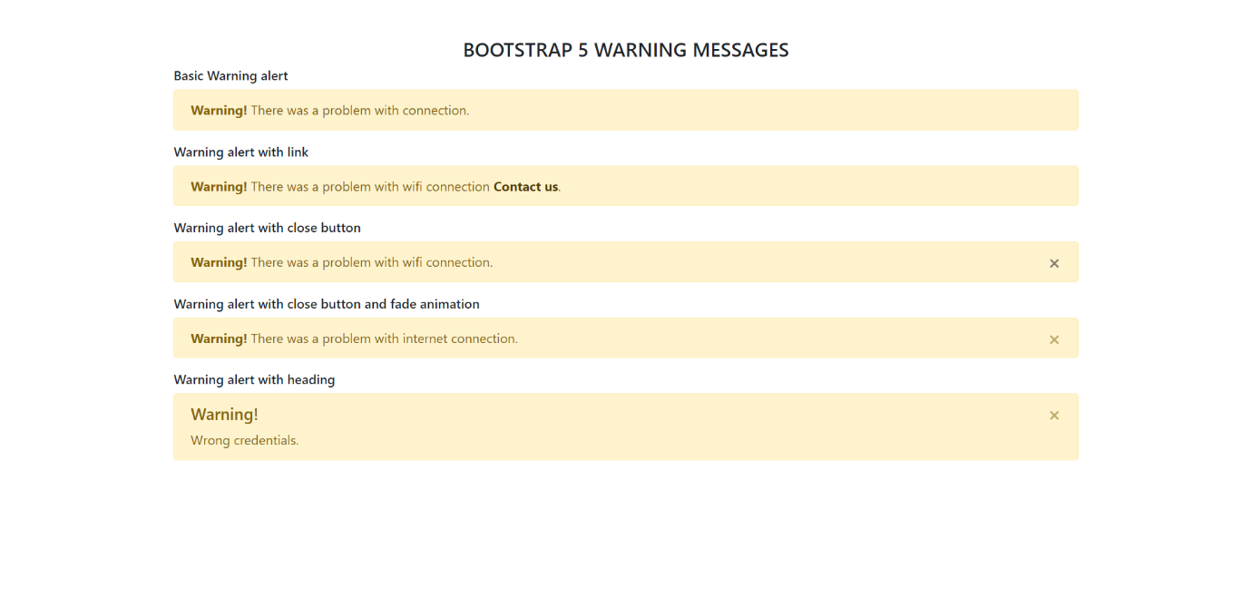

Example 2: In this example, we will use the warning alerts using the button click. When the user clicks the button, a warning alert will be generated.
<!DOCTYPE html>
<html lang="en">

<head>
<meta http-equiv="Content-Type"
content="text/html; charset=utf-8" />
<title>Buttons and alerts</title>
<link href=
"https://maxcdn.bootstrapcdn.com/bootstrap/3.1.1/css/bootstrap.min.css"
rel="stylesheet">
<script src=
"https://ajax.googleapis.com/ajax/libs/jquery/1.11.0/jquery.min.js">
</script>
<script src=
"https://netdna.bootstrapcdn.com/twitter-bootstrap/2.0.4/js/bootstrap-alert.js">
</script>
<script src=
"https://maxcdn.bootstrapcdn.com/bootstrap/3.1.1/js/bootstrap.min.js">
</script>

<script type="text/javascript">
$(document).ready(function () {
$('#success').click(function (e) {
e.preventDefault()
$('#message').html(`
<div class="alert alert-success fade in">
<button type="button class="close close-alert"
data-dismiss="alert" aria-hidden="true">
×
</button>This is a success message
</div>`);
})

$('#warning').click(function (e) {
e.preventDefault()
$('#message').html(`
<div class="alert alert-warning fade in">
<button type="button" class="close close-alert"
data-dismiss="alert" aria-hidden="true">
×
</button> This is a warning message
</div>`);
});
});
</script>
</head>

<body>
<div class="container">
<h2>Tops Technologies</h2>
<p class="lead">
Warning Alert message using bootstrap
</p>

<p>
<form method="post">
<button type="button"
class="btn btn-success" id="success">
Success
</button>
<button type="button"
class="btn btn-warning" id="warning">
Warning
</button>
</form>
</p>

<div id="message"></div>
</div>
</body>

</html>
Output:-
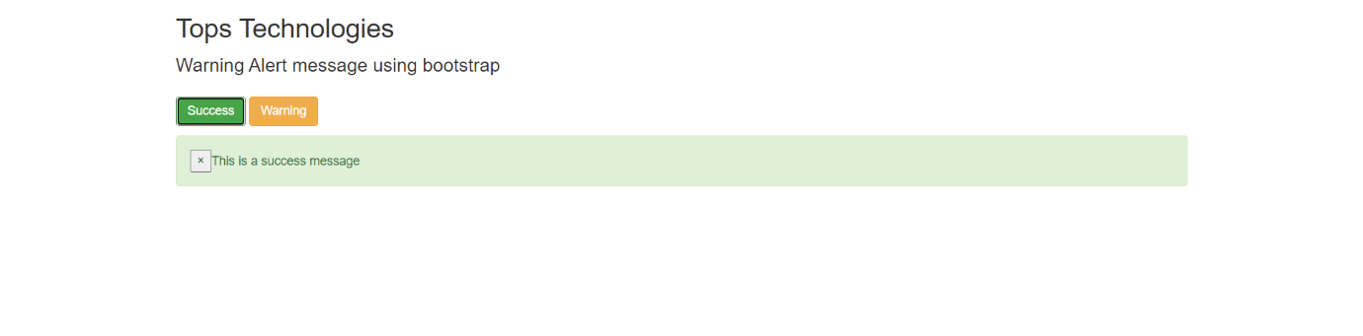
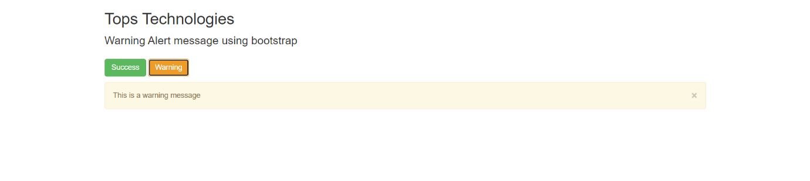
10. What is a bootstrap card and how would you create one?
Ans. <!DOCTYPE html>
<html lang="en">
<head>
<meta charset="UTF-8">
<meta http-equiv="X-UA-Compatible" content="IE=edge">
<meta name="viewport" content="width=device-width, initial-scale=1.0">
<title>Document</title>
<link href="https://cdn.jsdelivr.net/npm/bootstrap@5.0.2/dist/css/bootstrap.min.css" rel="stylesheet" integrity="sha384-EVSTQN3/azprG1Anm3QDgpJLIm9Nao0Yz1ztcQTwFspd3yD65VohhpuuCOmLASjC" crossorigin="anonymous">
<script src="https://cdn.jsdelivr.net/npm/@popperjs/core@2.9.2/dist/umd/popper.min.js" integrity="sha384-IQsoLXl5PILFhosVNubq5LC7Qb9DXgDA9i+tQ8Zj3iwWAwPtgFTxbJ8NT4GN1R8p" crossorigin="anonymous"></script>
<script src="https://cdn.jsdelivr.net/npm/bootstrap@5.0.2/dist/js/bootstrap.min.js" integrity="sha384-cVKIPhGWiC2Al4u+LWgxfKTRIcfu0JTxR+EQDz/bgldoEyl4H0zUF0QKbrJ0EcQF" crossorigin="anonymous"></script>
</head>
<body>
<div class="card" style="width: 18rem;">
<img src="https://images.moneycontrol.com/static-mcnews/2020/03/Ratan-Tata-HOB-3.jpg?impolicy=website&width=1600&height=900" class="card-img-top" alt="...">
<div class="card-body">
<h5 class="card-title">Ratan Tata</h5>
<p class="card-text">Some quick example text to build on the card title and make up the bulk of the card's content.</p>
<a href="#" class="btn btn-primary">Go somewhere</a>
</div>
</div>
</body>
</html>
Output:-
